Q1 : select onDate, onTime, i_staff_surname from lesson cross join instructor where i_staff_address = '27 Cherry Street';
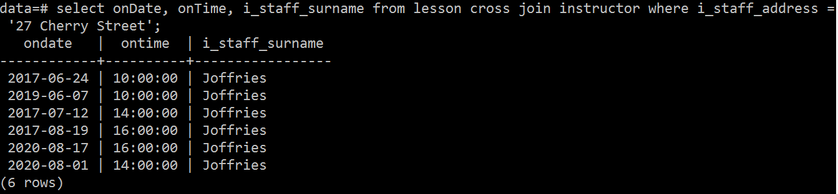
q2 : select test_status, count(test_status) from test , client where client.c_gender = 'F' and client.clientid = test.clientid group by test_status having count(test_status) > 0;
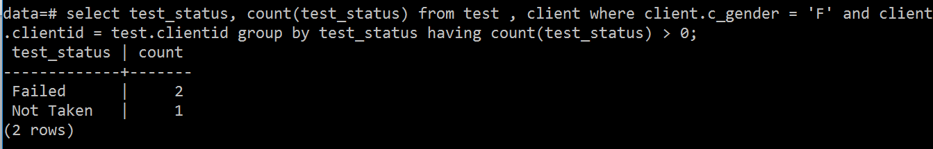
q3 : select empid,i_staff_forename,i_staff_surname from instructor where i_staff_surname='Joffries' union select empid,a_staff_forename,a_staff_surname from adminstaff where a_staff_surname='Joffries';
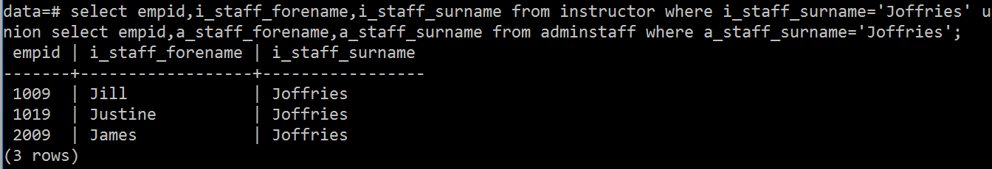
Q4: select s.school_address,s.schoolid,i.i_staff_forename,i.i_staff_surname from school s , instructor i where s.schoolid = i.schoolid and i.empid NOT IN (select empid from lesson);
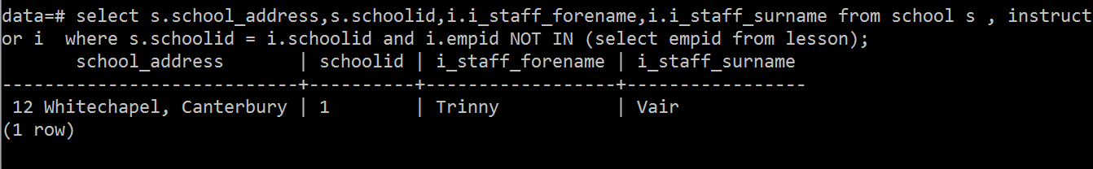
Q5 : SELECT onDate , onTime, test_status ,centreName ,c_forename,c_surname , school_address ,model FROM test t JOIN centre c ON t.centreID = c.centreID JOIN Client cl ON t.clientID = cl.clientID JOIN instructor i on t.empID = i.empID JOIN school s on i.schoolID = s.schoolID JOIN car ca ON i.carID = ca.carID WHERE centreName ='Whitstable'ORDER BY c_surname,c_forename;
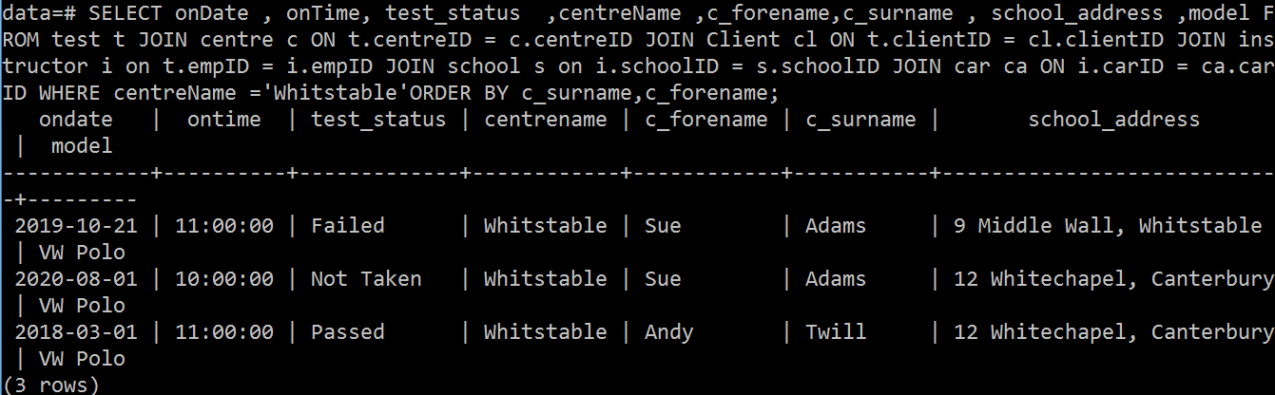

Q6 : update lesson set empID = '2011'where OnDate >= '2020-06-12' and empID = '2009';

